SUM OF INTEGERS FROM 1 TO N USING PROLOG
Aim
To write and execute a Prolog program to find the sum of all integers from 1 to N using recursion.
Objectives
- To understand the basic concepts of Prolog programming.
- To understand recursion in Prolog.
- To calculate the sum of integers from 1 to a given number.
- To understand facts, rules, and queries in Prolog.
- To execute the program using SWI-Prolog.
Algorithm
- Start.
- Read the value of N.
- Define the base condition: if N = 0, the sum is 0.
- Check whether N is greater than 0.
- Calculate N1 = N - 1.
- Recursively find the sum of integers from 1 to N1.
- Add N to the previous sum.
- Store the result in S.
- Display the final sum.
- Stop.

FLOWCHART
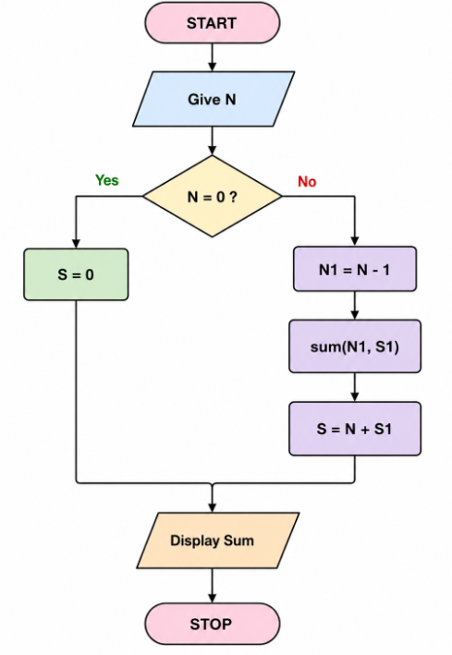
Program
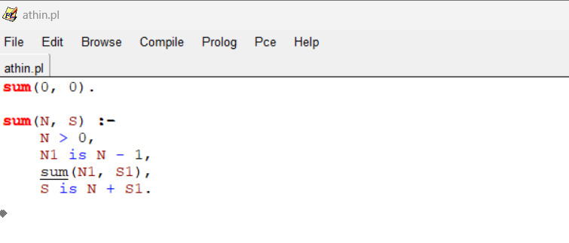
OUTPUT

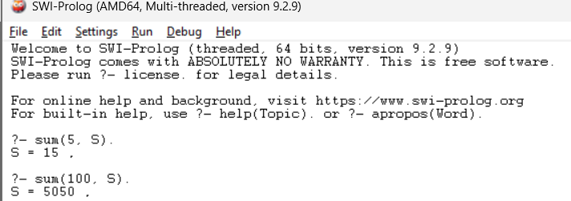
Result
The Prolog program was successfully implemented and executed to calculate the sum of integers from 1 to N using recursion. For the input N = 5, the obtained sum is 15.

